A000-Am,C-Taino-Behique-Shaman-Fossil Coral-1000 CE

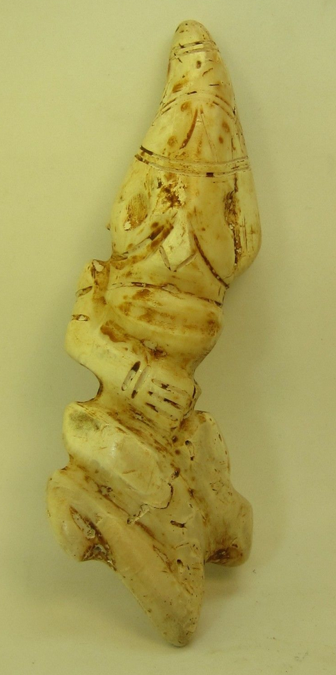 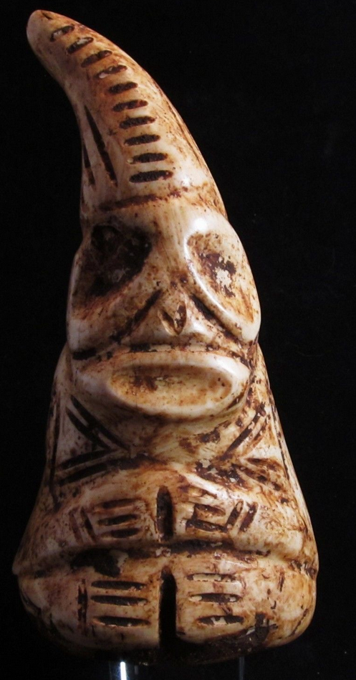

Am,C-Taino-Behique-Shaman-Fossil Coral-1000 CE

Figs. 1-2. Left: Behique-Shaman- as amulet with distinctive pointed cap, Puerto Rico, Fossilized coral, 6.5 inches long x 2.5 inches wide. Right: Dominican Republic (?), Shaman as amulet with distinctive pointed cap, Fossilized shell, ca. inches long 4.75 x 1.25 inches wide, private collection, valued $1200. Another example is found in Larry Roberts, Taino Sculpture: Art of the Gods (Micanopy FL, 2014), p. 27, Fig. 150.

Case no.: 18

**Accession No.**

**Formal Label:** Am,C-Taino-Behique-Shaman-Fossil Coral-1000 CE

**Display Description:**

The *Behique, Bohique or Buhitío* was a necessary personage in all the tribe, and occupied a privileged position in the social pyramid after the cacique and the *nitaínos*. "They represented the level of social and religious development of the Taínos" 1. The behiques possessed a "supernatural power" that made them respectable and feared people. Like the generality of shamans, they were not priests, but mainly doctor-sorcerers, although they also played the role of theologians, diviners and prophets.



A *Behique* seated on a *duho* ingesting *cohoba*. After https://i2.wp.com/farm1.static.flickr.com/137/326345667_60d85fd77c_m.jpg?zoom=2

To become a Behique, it required a very extensive learning and many days of fasting, practically absolute. "The fasting that some did mainly the *Behíques* or priests or sorcerers ... They fasted four months and more continuous, without eating anything, but only certain yerba juice or herbs, that only to sustain them, that they did not die, it was enough" 2

The functions that *Behiques* were in charge of included the following:

The *Behiques* were in charge of organizing the cult: The *Behiques* or shamans, along with the caciques, were the hosts of religious ceremonies or rites. Among them, the *Cohoba* Rite stands out, in which, after several days of fasting, they inhaled a hallucinogen called "*cohoba*" which consisted of seeds of a tree known as "*Anadenthera Peregrina*" and burnt snail shells, both pulverized. This dust provoked hallucinations and made them imagine that they had a talk with the gods, which gave them instructions on the actions they should take regarding certain situations. "The result was very dry and well-polished, cinnamon-colored mixes" 2

The *Behiques* were in charge of preserving and communicating the tribal traditions: The *Behiques* were also responsible for carrying out activities through which they passed on the knowledge acquired after many years of experience to the rest of the tribe, so that it would not be lost with future generations. An example of these rites is the *areito*, in which, as in the rite of the *cohoba*, they were drugged with hallucinogens and danced to the rhythm of maracas and drums. Medical knowledge was not shared because it was reserved exclusively for future shamans, who were to replace them.

The *Behiques* were in charge of educating the children of the caciques and to be advisors of these: Being the subordinate to the cacique, the caciques entrusted the Behiques with the education of their children, trusting that the *Behiques* would guide them along the path that the gods had prepared for them.

The *Behiques* were in charge of having sculptures or petroglyphs made in honor of different *cemíes*: The *Behiques* were in charge of elaborating the representations of the gods through a great variety of materials, such as stone and clay.

The *Behiques* were in charge of healing the sick: The latter distinguished them more than the others because of their vast knowledge in botany, medicine, and other branches; which gave them the privilege of being the only ones in charge of this trade. Of course these "doctors" of the tribe had no scientific knowledge of anatomy or physiology, they were purely intuitive. "They seem to have had certain knowledge in relation to the five main senses, taking into account that these functions put them in with the external environment, danger and survival." 3

**LC Classification:**

**Date or Time Horizon:**

**Geographical Area: Puerto Rico**

**Map:**

**GPS coordinates:**

**Cultural Affiliation:**

**Media:**

**Dimensions:**

**Weight:**

**Condition:**

**Provenance: Puerto Rico**

**Discussion:**

**References:**

